Computer Graphics Rendering of Seashells

Computer Graphics Rendering of Seashells

David Clarke
MSc in Computer Science

Supervisor: Dr. Ela Claridge

School of Computer Science, University of Birmingham

22nd September 2003

Table of Contents

- Abstract 3

- Introduction 5

- Design 6

- Shell Surface Algorithm Implementation 8

- User interface Implementation 17

- Project management 26

- Results 28

- Appraisal 30

- Conclusions 34

- References 36

- Appendices 37

Abstract

Abstract 1
This project is used to create a three-dimensional rendered seashell using the DirectX graphics library and functional algorithms. The program successfully achieves this via two distinct components, the shell rendering window and the function based user interface. The interface allows the user to alter the state of the shell structure and modify effects such as lighting and textures to achieve a realistically rendered seashell model. The shell program follows the project proposal faithfully, but doesn’t include facilities for the loading and saving of the shell structure. The system is very stable under all input conditions because the input data is predefined. Visual inaccuracies are still apparent, which relate to the lack of vertex normal calculations for the inner surface and the outer edges of the shell. There is still much scope for improving the coding methodologies and rendering effects used.

Keywords: Seashell, Render, 3D, DirectX, C++, MFC
Acknowledgements

Acknowledgements 2
I would like to thank the following people for their views and support:

Ela Claridge - Project Supervisor
Asim Farooq - Brother Farooq who showed me the light at the
end of the 3D spiral sweep path.
Georgios Theodoropoulos - Inspector
Antonio Diller - Inspector
GameDev DirectX Forum - Where the brains of DirectX help the less fortunate

Introduction

Introduction 3

Sea shells are aesthetically pleasing objects, each one has unique form, colour and texture. Their growth is periodic; hence their form can be described by simple mathematical equations. These equations can be used in a computer program to represent the shell’s growth path. Computer graphics techniques can then be employed such as sweeping to create a simple seashell structure. The shell structure consists of triangle graphics primitives, formed into strips and wrapped around the growth path. Graphical effects are introduced courtesy of the Microsoft Direct3D libraries. The graphics library gives scope for realistic synthesis of 3D shell models by employing accurate lighting and texture mapping.

This project aims to develop a user-friendly rendering tool for seashell creation. The program must be pitched at the level of a non-technical user. It should allow them to customise their shell structure, and in doing so, help the user visually understand how the mathematics and graphics relate to the 3D model.

On start up, the user is faced with a regular ammonite shaped shell. The user has a range of adjustable parameters included to the right hand side of the rendering window. There are two distinct sets of parameters, one relating to the customisation of the shell structure, the other relating the seashell’s graphical aspects. These predefined parameter variables are the only means of input to the system. The rendered image changes in reflection to these parameters. The user can change the lighting, texture mapping and transparency applied to the 3D model. The shell structure can be altered by varying the four main slider parameters verm, flare, spire and undulate. These values affect the cross sectional radius, scale, height and severity of ripples in the shell structure respectively. Once the user is satisfied with the shell they can then store the rendering by using the windows print screen function.

This remainder of this dissertation consists of a further nine sections. Following the introduction there is the high-level design (Section 3), shell surface algorithm (Section 4) and user interface (Section 5) implementations. A discussion on software management is described (Section 6). The results are presented in Section 7, detailing the various shell shapes that can be achieved with this software. The appraisal (Section 8) assesses how successful the software is. Finally, a discussion on how effectively the project has met its aims is concluded in Section 9.

Design

Design 4
The program is split up into four distinctive classes.

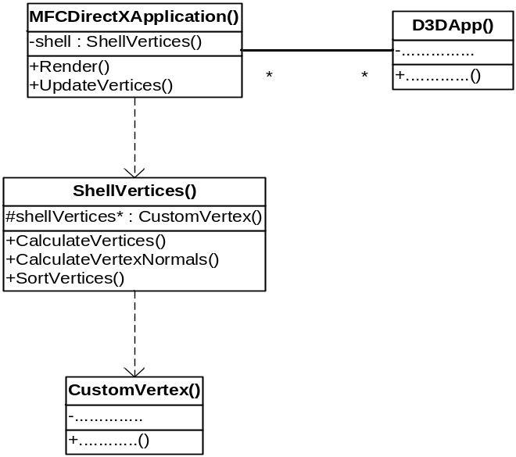

Figure 1: UML model of the class hierarchy

At the top of the hierarchy, lies the MFCDirectXApplication() class. This is the main file, which contains the integrated render and user interface functions. It ingeniously inherits the functionality of the Microsoft Foundation Class (MFC) structure, which provides the program with user interface functionality. The MFCDirectXApplication() class includes the services provided by the ShellVertices() class. The Shell Vertices class contains the number of CustomVertex() object elements required to display the shell structure. The D3DApp() works in conjunction with the MFCDirectXApplication() class to handle initialisation and closure of the program.

MFC interface items handle all shell transformations. When a button is clicked, slider moved, combo box changed etc. the MFCDirectXApplication() class handles it. The messages it receives from each of the interface items are mapped onto their specific handler function. Within these handler functions, the state of the user interface items is updated along with the state of the rendered shell.

There are three core algorithms that are used by the main program MFCDirectXApplication(). Every time the physical structure of the rendered shell is altered, the main program calls functions CalculateVertices(), CalculateVertexNormals() and SortVertices(). These are found within the ShellVertices() class and are used by the main programs UpdateVertices() function. CalculateVertices() uses the mathematics that calculates the 3D logarithmic spiral path. The graphics technique called sweeping is then implemented, which involves taking a 2D shape and moving it along discrete points on a path. The sweep shape is then mapped onto these points; the calculated vertices (points) contribute to the shells surface.
The CalculateVertexNormals() function contains an algorithm that calculates the vertex normals on the outer surface of the rendered seashell.
The SortVertices() function takes the calculated vertices and normals, then
These functions are explained in more depth in Section 4 of this report.

The shell’s construction could be implemented using a number of alternative methods. The first technique would involve creating a custom Direct3D mesh object. The vertex normals could then be calculated by calling one Direct3D function. This would’ve been the most efficient means of creating the seashell structure. However, very little documentation was available for such an implementation. In any case, allot of power would be taken away from me, the programmer. Such an approach would take away a low level understanding of the algorithms involved in creating a seashell shell structure.
The second alternative involved the use of an index buffer. Index buffers are buffers (or areas of memory) containing indices that are used in the rendering of graphics primitives. By implementing an index buffer, the SortVertices() function would not be required and duplicate vertices would not be produced. However, the algorithms used to generate the shell structure would be much more complex.

One of the main design decisions I took anchored on the viability of creating an effective user interface in the available time. There were two main ways of creating a GUI using visual C++, use either Microsoft’s Foundation Classes (MFC) or Microsoft Forms. The latter is the newest way of creating user interface components. However, MFC had better documented tutorials. The main problem apparent with GUI components balanced on how they would integrate successfully with DirectX 9 library. Documentation for this particular problem was difficult to find. The best answer available at the time was Microsoft’s DirectX/MFC template. The DirectX 9/MFC template was available in the Visual Studio .NET software package; it became available once the DirectX 9 software development kit was installed.

The only way I could see my rendering program working successfully with MFC was to create a new DirectX/MFC template derived program. Through trial and error I inserted my shell vertices code in place. The template provided the bare essentials i.e. the shell rendering display and an area where MFC GUI components could be placed. The functions available previously through keyboard via windows and DirectInput could now be made visible to the user via the interface. Using the Visual Studio resource window, templates of GUI components could successfully be ported to the DirectX/MFC template window. A message map was written for each component to link its action to the appropriate change in variable values. This simply meant writing a function for each GUI module then mapping it to that function. The function then simply read in the value and assigned the value to the appropriate variable.

Shell Surface Algorithm Implementation

Shell Surface Algorithm Implementation 5
The bulk of the ShellVertices() class was contained within three functions that were used to calculate all the vertex attributes associated with the shell surface. The majority of get and set methods within this class were used to update the parameters within these three functions. Their implementations are described in this section.

Implementing the Shell Structure’s Vertices Calculation

The rendered shell is based on the logarithmic spiral and linear models. The linear model projects the sweep path along the x-axis only by incremental radius values. The orientation of the shape, which is swept along this path, is never altered. Therefore fewer transformations are required to generate the shell surface.
The mathematics used in the linear model implementation is simple and are not worth discussing. However the implementation of the logarithmic spiral path does need attention and is described below.
x
x

z₀
r₀
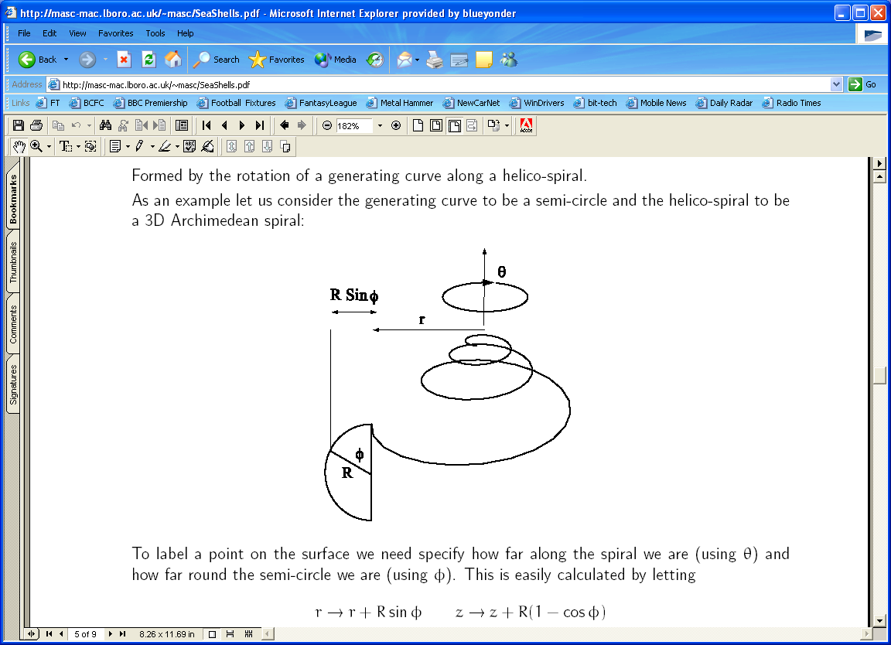
Δθ
y
z
y
z

Figure 2: Logarithmic Spiral Model with associated attributes Figure3: Close up view of the top of the logarithmic spiral

Initial values for the following constants and variables are chosen:

θ₀ – The angle from which the spiral begins, in the case of this program assume to always be zero.
Δθ - Difference in angle between neighbouring vertices taken along the spiral.
λ – A scale factor that increases with each successive vertex along the spiral path.
r₀ – the initial length of the spiral radius
z₀ – the initial depth of the spiral

These variables and constants are substituted into the following equations. Each equation depends on a variable (i) i.e. the loop iterator value, which begins at the value zero and increases every iteration.

θ_{(i+1)} = Δθ
r_{(i+1)} = r_{i} x λ
x_{(i+1)} = r_{(i+1)} cosθ_{(i+1)}
y_{(i+1)} = r_{(i+1)} sinθ_{(i+1)}
z_{(i+1)} = z_{i} x λ

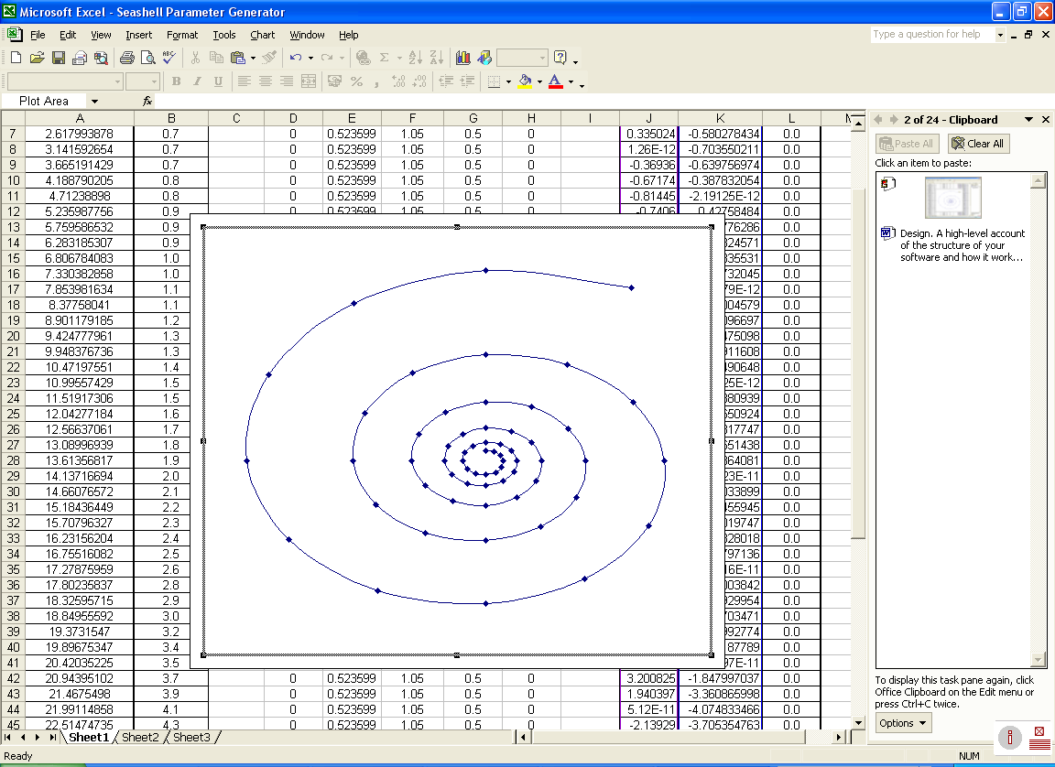
x
r
y
θ

Figure 4: Front view of the spiral sweep path

Shown in Figure 4, at each point along the logarithmic spiral path, the radius used in the calculation of its position can be split into its respective x and y components. The z coordinate is calculated directly by multiplying it with current value of the spiral scale factor λ.

The shell surface itself is made up of many vertices. A vertex is defined as a point where two edges of a shape come together. In Direct3D, each vertex has a number of attributes associated with it including:

- Positional Coordinates
- Vertex Normal Coordinates
- Transparency
- Texture Coordinates

The positional and vertex normal coordinates are of most importance. The positional coordinates quantify the position of the vertex in 3D space. The vertex normal position specifies the direction in which the light should reflect off the object. In a world where there is a light source, vertex normals must be specified else the object would not be visible. Both the positional and vector normal coordinates are of a type D3DXVECTOR3, a 3D vector type available in the Direct3D library. Due to the size and extensibility of the vertex, it is given its own class, CustomVertex().

CustomVertex() objects are collectively used in a class called ShellVertices(). ShellVertices() handles the calculation and storage of all CustomVertex() objects. Within the ShellVertices() class there is a function that calculates the position of the shell vertices called calculateVertices(). The algorithm used to calculate the sweep surface vertices within the calculateVertices() function is described below.

x
y
V3
Radius of Cross-section

V2
V0
z
z

V1

Figure 5: An example of how the sweep shape is constructed, specifying NOOFCIRCLEVERTICES = 4.

The number of cross-sectional vertices in this program can be changed from 1 to a given limit. The calculateVertices()function allows this by assuming that the shape of the cross section is based on the circle template. By increasing the number of cross-sectional vertices, the cross-section becomes more and more like a circle (from now on the shape used in the sweep algorithm will be assumed circular). The algorithm can be explained thus:

Given the radius of the initial cross-section is a constant. CIRCLE_R = C.
Iterate through the loop.
Within that loop calculate the angle at which the cross-sectional radius should be rotated to. Place the current circle vertex at that point. Calculate the y and z coordinates of the circle vertex given the equations CIRCLE_R*sin(angle) and CIRCLE_R*cos(angle) respectively (all the cross-sectional coordinates have an x coordinate value of 0). Save the vertex position coordinates in a D3DXVECTOR3 array of size NOOFCIRCLEVERTICES.
Exit loop when the iterator equals the NOOFCIRCLEVERTICES.

Once the vertices for the sweeping circle have been calculated, they then can be used in the calculation of every shell vertex that constitutes the shell. A number of steps are followed in the calculateVertices() function that do this:

Two loops are set up to calculate the corresponding position of each shell surface vertex position. The outer loop iterates through the number of sweeping circles whilst the inner loop iterates through each of the sweeping circle vertices. In the outer loop the spiral point position parameters are updated. These parameters are fed into three matrix transformation functions:-

- D3DXMatrixScaling
- D3DXMatrixRotationZ
- D3DXMatrixTranslation

y
x
z
y

Figure 6: Circle cross section, after being rotated by the desired amount about the centre of the axis

The DirectX function D3DXMatrixScaling is used to scale the cross-sectional circles vertices in the y and z planes in proportion to the value of the current spiral radius. A general aside, the undulate function works on the basis of adding an extra D3DXMatrixScaling factor. This factor is activated using a conditional statement within the inner loop. If the circle coordinates belong to an odd numbered circle within the sequence, then its points are scaled according to a global variable undulate. If the value of undulate is one, the surface appears smooth, else is undulated. It is assumed for this example that the value of undulate is one.
The function D3DXMatrixRotationZ is used to rotate the cross-sectional circle vertices about the z-axis by a spiral point angle separation of theta.

y

x
x
y
x
y

Figure 7: Circle cross sections that have been rotated and translated to their respective points on the spiral sweep path.

D3DXMatrixTranslation is used to translate the cross-sectional circle to the specific point on the spiral. The inner loop is used to apply these three transformations to all the cross-sectional points.

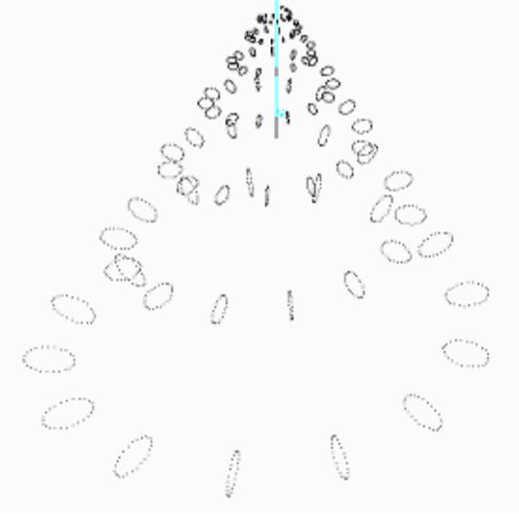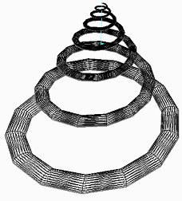
y
z
x
x
y
z
Figure 8: A point model showing how the circle cross Figure 9: A wireframe model showing the lengths of triangle
sections are arranged on a 3D spiral. strips.

Within the inner loop, after the sweep transformation has been applied there are a number of steps that must be followed. The three dimensional coordinates, which are stored in the resultant 4x4 matrix must applied to a CustomVertex()object. A new CustomVertex()object called vertex is created. Its coordinates are set using the CustomVertex(), setCoordinates()method. This takes the x,y and z coordinates of the circle point as parameters. The vertex normal and transparency attributes of the CustomVertex() are initialised using the setNormal() and setTransparency() methods respectively. The vertex normal direction is set to zero (this calculation is carried out in a separate method), whilst the surface is set to semi-transparent.

Before going straight into the details of the texture mapping algorithm, texture coordinates need to be explained. Texture coordinates tell Microsoft Direct3D which the part of the texture should be applied to the surface. Each vertex has a two, two dimensional texture coordinate attributes associated with it. These texture coordinates have are float values that range from 0.0 to 1.0. The texture coordinate 0.0, 0.0 specifies the texture’s upper left hand corner, whilst the coordinates 1.0, 1.0 specifies the textures lower right corner.
1.0, 0.0
0.0, 0.0

1.0, 1.0
1.0, 0.0

Figure 10: Applying the texture map to a polygon

In the case of this program the texture spans every two of the sweep circles and follows the circumference of the shell cross-section i.e. the width of the texture is the distance between adjacent circles and its length is the circumference of the shell. Hence the texture, which stretches the circumference, for the (NOOFCIRCLES – 1) segments. The algorithm used to assign the correct mappings does the following.

- If the circle points are associated with an even sequence numbered circle then the x coordinate of that vertex is assigned 0.5, else its assigned 1.0.
- According to which circle vertex is being processed. If the circle vertex is the first in the sequence, the y-coordinate is assigned the value 0.0. If the circle vertex is the last in the sequence it is assigned a y-coordinate value of 1.0. The points in between are assigned a value proportional to their sequence in the circle multiplied by a factor (1/NOOFCIRCLEVERTICES).

Once these attributes for each vertex have been calculated, it is then stored in a CustomVertex() array called shellVertices (which has the same name as the class, but that’s as far as it goes). This calculation is repeated for the remainder of the shell surface vertices.

Implementing the Vertex Normal Calculation

As mentioned before, each vertex of type CustomVertex() has position and vertex normal coordinates. The positional coordinates calculation has been described above; all that needs calculating is the vertex normals. This calculation is dealt with by a user defined function called calculateVertexNormals(), found within the ShellVertices() class. Its implementation can be understood better by using a number of diagrams.
0th row
1st row

Near edge
Far edge

(n-1)th row

Figure 11: A wire frame flat packed shell surface model, used to illustrate the vertex normal calculation.

One could think of the shell as a 2D flat packed surface. There exist three algorithms that can be used to calculate the vertex normal at each vertex (excluding vertices on the near and far edge of the shell surface). Of the three algorithms, which one is used is dependant on the vertex position. The first algorithm is chosen if the vertex lies on the Oth row, the second if the vertex lies on the 1st row and the third’s chosen if the vertex lies on the (n-1)th row. The reason there are three separate algorithms is because of the numbering system used to define the vertices. The number represents its position in the one dimensional array that stores custom vertex objects within the ShellVertices() class. Hence unconventional algorithms are required to cater for these three situations. In each case (excluding the near and far edge vertices) the following algorithm can be applied, but obviously numbers differ for the 3 cases.

7
15
23

0
16
8

1
9
17

Figure 12: Surrounding vertices used in the vertex normal calculation of vertex number 8.

Take for example the vertex normal calculation for vertex 8.
Take the uppermost and upper rightmost vertices, vertex 15 and 23. Take each pair of vertices, working in a clockwise direction
- Subtract the coordinates of vertex 15 from vertex 8 (call this result1).
- Subtract the coordinates of vertex 23 from vertex 8 (call this result2).
- Calculate the cross product of the two vectors. Call the result, result3.
- Add result 3 to a moving sum.

The subtraction of the 3D coordinates and the calculation of the cross product are calculated using DirectX functions D3DXVec3Subtract() and D3DXVec3Cross() respectively.

Move to the next vertex
- Subtract the coordinates of vertex 23 from vertex 8 (call this result1).
- Subtract the coordinates of vertex 16 from vertex 8 (call this result2).
- Etc

After this algorithm has been used on each pair of vertices, normalise the moving sum using the DirectX function D3DXVec3Normalize().

Iterate through the array of CustomVertex() objects, using the above algorithm until the vertex normal for each vertex has been calculated. The vertex normal is set using the CustomVertex’s setNormal() method.

Figure 13: Arrow illustrating the resultant direction of the vertex normal

Implementing the Sort Vertices method

In Direct3D once the vertex data has been specified, its values must be stored in the vertex buffer. To create the vertex buffer, the Direct3D function CreateVertexBuffer()is utilized. The function is past parameters such as the number of vertices to be stored and their format.
The kinds of information inherent to each vertex (position, vertex normal direction, texture coordinates etc.) are managed in Direct3D using flexible vertex format (FVF) flags. The FVF flags contain formatting information about each vertex. The information provided by these flags is used by the program to correctly interpret the vertex data and display it to the screen.
Up until this point, the positional and vertex normal coordinates have been calculated. However, there is one more step required before the vertices can be passed to the vertex buffer for rendering. The vertices need to be correctly ordered. When the main program is rendering it must be told which type of primitives will be displayed. DirectX has six predefined primitive types:

- Point lists – a list of individual points
- Line lists – a list of individual lines
- Line strips – a list of connected lines
- Triangle lists - a list of individual triangles
- Triangle strips – a list of connected triangles
- Triangle fan – a list of triangles connected into a fan shape

For reasons of economy (i.e. less vertices need to be stored), triangle strips were used. In order for the triangles to extend along one plane they must be ordered appropriately.

1
3

1
3
0
2
4

0
2

Figure 14: Example of how vertices are organized in a triangle strip, which constitutes one division of the shell surface.

Each triangle strip was constructed along the length of the shell surface. If the number of vertices specified for the shell cross section were greater than 2, the triangle strips that were created share edges i.e. at each and every vertex, pairs of vertices are positioned.
Each triangle strip is consecutively stored in a CustomVertex array called shellVertices which is stored in the ShellVertices() class.

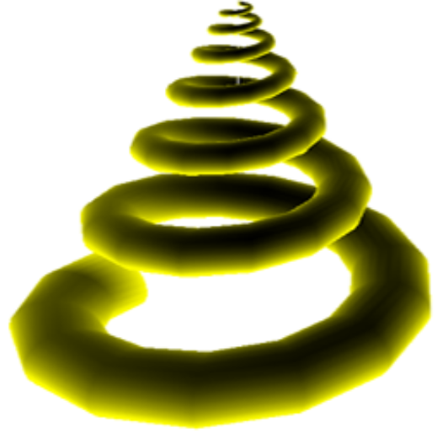
z
x
y
Figure 15: An example of how the spiral is finally rendered after the three algorithms have been applied.

The previous three algorithms were utilised extensively when updating the shell vertices. This function was employed in the rendering cycle contained within the main program. The rendering cycle can be described in the following way:

Input – Process input from keyboard and GUI
Render – Update Shell Vertices
Draw objects

In the latter stages of the project, it was thought appropriate to include additional axes to the rendered scene. The x, y and z axes were drawn simply using individual line lists. The axis labels were created using the InitText() function within the main file. Each label is simply a predefined Direct3D mesh model. Its vertex normals are calculated using Direct3D’s D3DXComputeNormals() method. It is drawn within the render loop by calling DrawSubset(). The DirectX/MFC template generates the statistics that are found at the bottom of the screen.
User interface Implementation

User Interface Implementation 6
From the outset the user interface was going to be a substantial part of the project. The interface allows the user to intricately change the shells look and feel by changing a number of parameters. The interface is split into five main sections, these include: -

- Shell Parameters functions - - - -
- Texture Mapping functions - - - -
- Rendering Mode functions - - - -
- Lighting Control functions - - - -
- View Control functions - - - -

These functions are illustrated in the Figure 16 using the dashed line key colours.

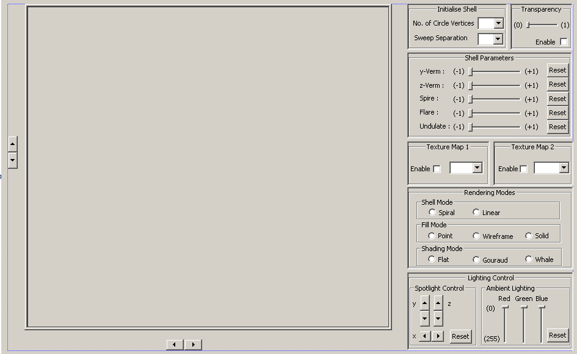
Figure 16: Colour coded GUI

In the following sections, the above functions will be described in more detail. The description includes details of how all of the GUI items are implemented. Please note, all MFC GUI items were created using the resource viewer program, found within the Microsoft Visual Studio .NET software package. The resource viewer allows dragging and dropping of GUI items onto the canvas of the application. Changing its property values in the property sheet panel alters the look and feel of each item. Visual Studio handles all this. The GUI item message mapping and the contents of the message mapping function are programmed manually.

Shell parameter functions

When the main program is run, a ShellVertices() object is initially instantiated, called shell. This instance uses the default ShellVertices() object constructor which initialises all the shell’s attributes. The attributes of interest here are NOOFCIRCLEVERTICES, CIRCLE_SEPARATION and NOOFCIRCLES. Whilst the first two variables were available in the user interface for the user to vary, NOOFCIRCLES was not. The effect NOOFCIRCLES had was too similar to CIRCLE_SEPARATION. The CIRCLE_SEPARATION parameter employed fewer vertices; hence the NOOFCIRCLES attribute was dropped from the GUI.
Two CComboBox items were employed to control the variables NOOFCIRCLEVERTICES and CIRCLE_SEPARATION. These combo boxes were contained within the group box called “Initialise Shell”. The NOOFCIRCLEVERTICES combo box varied the number of vertices in the shell sweep cross section whilst the CIRCLE_SEPARATION combo box altered the separation between neighbouring cross sections.
The items that were selectable from the combo boxes were programmed in the data section of the property panel. This was also where the CComboBox’s type was changed to droplist, which means that the combo box has only selectable values. The property panel was used to change the combo boxes associated identification codes (ID) from Visual Studio’s standard name to one, which was better associated with the device. The next course of action was to map the combo boxes selections to the visual state of the 3D shell. Using MFC message mapping macros, when the combo box was selected an ON_CBN_SELCHANGE message is always inputted to the main program. The program checks the ID of the combo box and calls its corresponding function. Each combo box has its own mapping function that deals with each activated combo boxes. In both the combo boxes message map functions, using the GetCurSel function retrieved the state of the combo box. This obtained the current combo box selection (the first has the index 0). The selection was then used in a case statement. If the CIRCLE_SEPARATION combo box was altered then the OnCbnSelchangeCombo4() message map function would be entered and the shell setCIRCLE_SEPARATION() function called with the specified value. On the other hand if the NOOFCIRCLEVERTICES combo box was changed then OnCbnSelchangeCombo2 would be entered and the shell setNOOFCIRCLEVERTICES()function called with the specified value. Both of these functions only change the value of the shell objects implicit parameters. They do not however update the structure of the seashell. To do this, calls to the shell objects calculateVertices(),calculateVertexNormals() and sortVertices() functions must be made. These function calls are all contained within the main file’s UpdateVertices() method. This is called to visually update the rendered shell in the window.

The group box called “Shell Parameters” consists of five sliders. These sliders of type CSliderCtrl are used to change the yVerm, zVerm, flare, spire and undulate shell attributes. The way in which these parameters affect the state of the shell structure is described below:

yVerm – The name ‘verm’ is derived from the word ‘vermiform’, meaning ‘worm-shaped’. If the yVerm value is 0.5, this means that the distance from the centre of the spiral to the inner wall of the shell surface is half the distance from the centre of the spiral to the outer wall. Varying the yVerm value has the affect of scaling the shell cross section in the y-plane.

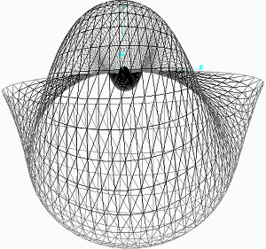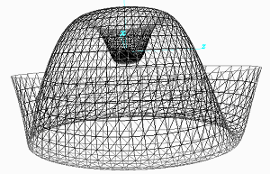
Figure 17: A before and after picture, of yVerm being applied.

zVerm – Varying the value of zVerm has the effect of scaling the cross section of the shell in the z-plane.
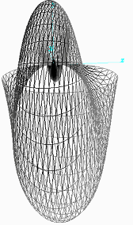
Figure 18: A before and after picture, of zVerm being applied.

Flare – Is a measure of the rate of expansion of the spiral path. Given a flare value of four, for every turn of the spiral path, the shell opens out four times its subsequent size. This has the affect of scaling the complete shell.

Figure 19: A before and after picture, of Flare being applied.

Spire – Can be thought of how successive whorls of the spiral sweep passage move along a linear path in the third dimension. A spire value of zero corresponds to a spiral sweep path in the x and y planes only. A non-zero value spire value corresponds to a spiral sweep path that is extended along the additional z plane.
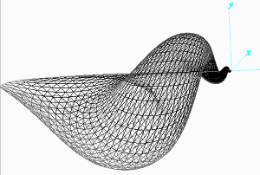
Figure 20: A before and after picture, of the spire parameter being applied.

Undulate – Affects the unevenness of the of the shell surface.
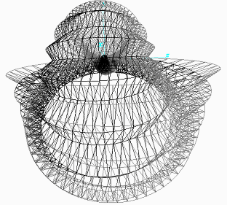
Figure 21: A before and after picture, of the spire parameter being applied.

Each slider has a corresponding reset button of type CButton. Within the main program, the OneTimeSceneInit method was used to double the sliders range (increased from 100 to 200 units) and set the slider to a half way position.
The actions of all the sliders within this group are handled by a single message map function called OnHScroll(). The OnHScroll() function is MFC component independent i.e. any component that has scroll bar properties activates this function.
If one of the shell parameter scroll bars is activated, OnHScroll() is entered. The UpdateVertices() function is initially called to change the state of the current rendered shape. The value of each shell parameter scroll bar is checked and multiplied by an appropriate factor. The current value of each slider is then passed to its corresponding ShellVertices() set method. Within ShellVertices() the slider value is offset and divided by a suitable factor. The updated vertices are passed into the vertex buffer and appropriately rendered in the main files Render () function.
The reset buttons simply set the position of the corresponding slider back to zero. The shell parameters set method is then called, passing the sliders zero position. The update vertices method is then called to update the rendered shell.

Texture Mapping functions

When the program is initiated, the texture mapping functions evident in the Texture Map 1 and Texture Map 2 group boxes are disabled. There are two levels of texture mapping available to the user, Direct3D can handle a maximum of eight. The manners in which the textures are applied to the shells surface are initiated at the start of the program. Also on initiation, the InitTexture() method is called with parameters (6,6), allowing the relevant two textures to be selected and then loaded. Within the InitTexture() function the texture stage state is set up to allow each texture to colour blend with the surface below it.
The texture is selected by using CcomboBox GUI items. Each combo box holds a number of predefined texture names that are stored in the project directory. A tick box is used to independently enable and disable each texture. When either texture map enable tick box is ticked the message is mapped to either of the OnBnClickedTexCheck functions. In this function the state of the check box is retrieved. The state of the check box is copied to a global variable, which is used by some of the other main file functions (described shortly). The value of the tick box is then used in a control statement to determine if the combo box is to be enabled or disabled. If an enabling signal is retrieved, the global variable is set to one and the combo box window is enabled.
The only means in which the texture map can be applied is by calling the set texture method within the main program’s render function. To enable/disable the setting of the texture, the setTexture() function is placed within a control statement. Two global variables are used to monitor the enabling and disabling of the available texture maps. When one/the other or both textures are enabled, the textures initially default to those selected at start up.
With either texture enabled, when the user chooses a predefined texture, the OnCbnSelchangeTexCombo1 or OnCbnSelchangeTexCombo2 function is entered. The state of both the texture combo boxes is inputted. The current combo box selection is obtained by using the GetCurSel()function. These values are then passed on the call to the function InitTextures(). InitTextures() simply sets up both textures according to the value passed with the function.

Rendering Mode Functions

Most of the selections available within the rendering modes group box affect the way in which the shell surface is rendered. All GUI controls in this group are radio buttons of type Cbutton. The rendering mode group is subdivided into smaller groups:

- Shell Mode - choose either a spiral or linear sweep path
- Fill Mode - Point, wire frame or solid fill
- Shading Mode - Flat, Gouraud or whale shading

The subdivided groups each had a separate group box. The radio buttons belonging to each group were placed in the confines of their group box. At least one radio button per group box had its properties panel’s group attribute changed to TRUE.
The shell mode options were produced towards the end of the project. By changing between the spiral and linear sweep path mathematics didn’t prove too difficult. All that was needed was a decision mechanism in the calculateVertices() function of the ShellVertices() object. The sweep mode is passed in via a call to the ShellVertices() setSweepMode() function, passing with it an integer parameter. The value passed to the setSweepMode() function is then made global, the calculateVertices() function accesses it to activate the correct sweep mode.

The fill modes were very easy to implement. By default Direct3D applied the solid render state, hence on initialisation the solid radio button was made active. The radio buttons were all message mapped to the same function. Within this function the value of each button is discovered using the MFC GetCheck() method. Only one is active (at logic 1) at any one time, hence only one render state is chosen. The fill mode is altered by using the Direct3D setRenderState() function. This is used to specify which type of render state is required (in this case Fill mode) and the value (Point, wire frame or solid fill).

The shading mode radio button subgroup works in very much the same way as the fill mode functions. There is one exception to this group that does not use the Direct3D render state function and that is “Whale shading”.
The shading modes flat and Gouraud are described as follows. When Direct3D flat shading is implemented, a polygon is rendered, using only the value of the first vertices material colour. In this mode sharp edges appear between adjacent polygons when rendering the 3D object. When Direct3D Gouraud shading is implemented, the colours of all vertices are used in the computation of the colour assignment of each polygon.
“When Direct3D renders a polygon using Gouraud shading, it computes a color for each vertex by using the vertex normal and lighting parameters. Then, it interpolates the color across the face of the polygons The interpolation is done linearly. For example, if the red component of the color of vertex 1 is 0.8 and the red component of vertex 2 is 0.4, using the Gouraud shading mode and the RGB color model, the Direct3D lighting module assigns a red component of 0.6 to the pixel at the midpoint of the line between these vertices.” (taken from [3] in the Reference section)
The following figures demonstrate flat and Gouraud shading of a simple seashell shape. Notice the smoother, more rounded surface of the Gouraud shaded model.

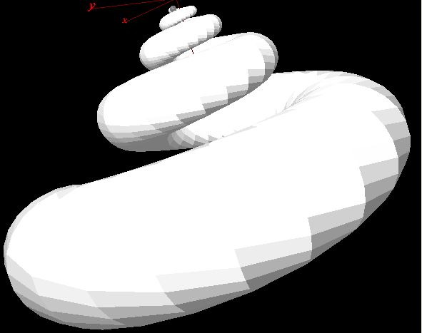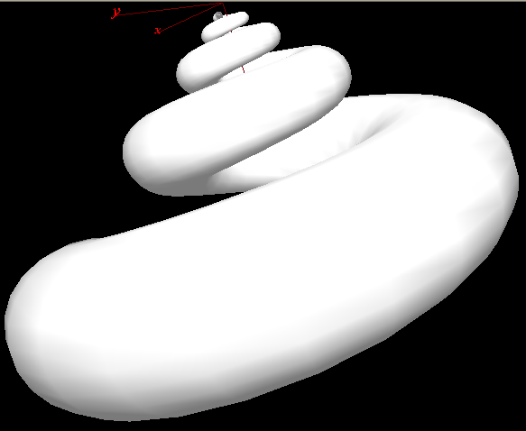

Figure 22: Example of Flat Shading Figure 23: Example of Gouraud Shading

Whale shading is a new concept that was stumbled upon whilst experimenting with vertex normal calculations. The new concept is used within the sortVertices() function found within the ShellVertices() class. When the user activates whale shading, the ShellVertices() setWhaleShading() function is passed a true Boolean value. This value is used to activate a control statement found at the tail end of the sortVertices() function. The algorithm found within the control statement is used to add vertex normals to the repeated vertices. SortVertices() replicates vertices in order for them to be inserted correctly into the vertex buffer. Each row of repeated vertices have their vertex normal orientation reversed. This has the effect on each triangle strip, shading them from white to grey i.e. ridges are formed between adjacent triangle strip.

Light Control Functions

The most simple but impressive rendered displays are created using the lighting inherent in Direct3D. Direct3D can handle a number of light sources, however the increase in number, effects performance and increases the complexity of the rendered scene. The program handles two types of light, ambient and spot lighting. These different forms of lighting can only be applied to a 3D object that has a Direct3D material interface. Once created, the material can be configured to react to the different light sources. In the case of the 3D shell object, it is initially set up to reflect all the ambient and spotlight in the scene. Thus the object appears to have a white appearance, when white light is shined upon it. The shell can also reflect any colour light present in the scene.
The levels of ambient light available in the scene can be altered using the ambient light slider controls. These CsliderCtrl GUI items are vertically oriented; this is a quality that can be change using the Visual Studio properties page. All sliders are initilised in the main file’s OneTimeSceneInit() function. Each slider represents an ambient light colour component; there are 3 sliders, one for red, green and blue. Each slider has its own separate message mapping function that reads in the current light value. On initialization there is half red, green and blue ambient light components available in the scene i.e. the scene is lit up by a grayish glow. The shell appears white due to the spot light component, but this will be discussed later. By altering the position of a particular slider, a corresponding global variable in the main file is changed, which in turn is used in the Direct3D set render state to alter the value of the particular ambient light component. All lighting is taken care of in the main file, and is updated every pass through the render loop. The only other component to mention in the ambient lighting group is the ambient light reset button. This is used to initialize the ambient light sliders and lighting levels.

The spotlight control was an extra function implemented towards the end of the project. The spotlight is a Direct3D component that has colour, direction and position. The light it produces is cone shaped and is more intense towards its centre. The spin buttons control how the spot light is translated in the x, y and z domains. These translations in the different domains are stored in global variables lightSpherePositionX,lightSpherePositionY and lightSpherePositionZ respectively. Direct3D does not produce a physical spot light object on the screen, which monitors its position. The spotlight has a positional attribute, which can be altered by the program. If its position is known then a 3D object can be positioned at it’s beginning to monitor its movement. Most spotlights are circular in cross-section. With this idea, a number of objects sprung to mind. The simplest to install however was the sphere Direct3D primitive mesh shape. Direct3D handled the creation of the mesh sphere. There was even a function to calculate its vertex normals. This allowed quick and simple installation of the spotlight object. The only problem encountered was to do with the spotlight objects position. The 3D spotlight object needed to be kept stationary with respect to the 3D shell, when the shell was rotated. This didn’t prove to be as difficult as once thought.
All world and camera rotations are handled by the InitMatrices() function in the main file. The InitMatrices() function works by passing it values for the world coordinates of the particular object and the type of 3D object to be rendered. If the 3D object in question is the spot light sphere, the coordinates that are input are used just to translate it. However if the 3D object is the shell then its world coordinates are always translated by (0,0,0) and rotated. Using numpad arrow keys rotates the shell; the state of these rotations is monitored by global variables xWorldRotate and yWorldRotate. These global variables are used by the InitMatrices function to calculate the degree in which the shell object is to be rotated.
So, to reiterate, the spotlight object is only translated, the amount its translated by is controlled by the spotlight controls spin buttons. The shell objects world coordinates are always translated by (0,0,0), but its rotation can be altered using the numpad keys.
The spotlight control group’s reset button is a simple MFC Cbutton. It is used to initialise the global variables lightSpherePositionX,lightSpherePositionY and lightSpherePositionZ that monitor the spotlights position.

The transparency group box consists of an MFC slider and tick box. On start up the slider is disabled, the slider position is set halfway and the enabling tick box is not ticked. The transparency tick box is message mapped to a function called OnTransparencyCheck(). When the tick box registers an action, this function is entered. The state of the tick box is then obtained. If the tick box is ticked then the transparency slider is enabled and the Direct3D renderstate D3DRS_ALPHABLENDENABLE is set to true. With the slider set to halfway the 3D shell object appears 50% transparent. If the slider position is altered, the OnNMCustomdrawTransparencySlider message map function is entered. The function checks that the value of the ‘transparency enable’ tick box. If ticked, the ShellVertice’s setAlpha method is called, specifying the current slider value. The alpha value is an attribute of every CustomVertex in the 3D shells makeup. After changing the alpha value of the all the ShellVertices, a call to the main programs UpdateVertices() function recalculates the vertex data ready for rendering.

View Control functions

The scene camera can be translated in two dimensional space by using the pair of spin button controls to the left and bottom of the shell rendering window. The state of the camera translation is stored in two global variables named horizSpin and vertSpin , found within the main file. When either pair of spin buttons are clicked on, methods OnDeltaposSpin1() and OnDeltaposSpin2() are activated. Within these methods the spin button value is obtained, which can be either 1 or -1. This value is scaled and added to either the horizSpin or vertSpin global variables. These values are used by the InitMatrices() method to change the respective values of the horizontal and vertical camera view coordinates.
Four designated keyboard keys are used to control the rotation of the rendered shell in its world coordinate system. The state of the keyboard is monitored wholly by DirectInput (a branch of DirectX that handles all known input devices). The operation of the keyboard is initialised and set up in the InitDirectInput() method found within the main file. The keyboard actions are acquired using the ViewDirectInputState()method. This method contains four control statements, which are used to change the values of global variables xWorldRotate or yWorldRotate. These globals are utilised by the InitMatrices() method to rotate the world coordinates of the shell and axes about the x and y axis respectively.

Project management

Project Management 7

In the eleven weeks that were put aside for the completion of the project, a great deal of time was used to research and learn basic techniques.
In the projects initial stages, a number of problems had to be addressed:

- What algorithms were needed to produce the rendered seashell?
- How were these algorithms going to be implemented? What programming language should I use and what libraries were available to implement 3D graphics.

The first problem was dealt with by looking up as many seashell references that I could possibly find using the Internet search engines. The search proved successful, and a number of references to books were found and used. The algorithms found in the Internet research papers and books became the backbone of my project.

The second problem was again dealt with by searching the Internet. A table of programming languages versus the availability of graphics libraries was setup. It became apparent through this research that the most up to date and powerful graphics library was DirectX Graphics 9. It was apparent that the DirectX graphics library was most commonly used by C++ programs.

The initial research helped immensely in writing the project proposal (see Appendix 1). The proposal detailed what the project was about and how it would be approached. A number of goals and requirements were stated to complete a particular stage. Realistically the project could be completed by finishing the first 2 stages; the final 2 stages were regarded as extensions.

In accordance with the time line that was stated in the project proposal, coding of the program would start in week four. The timeline up to this point was followed accurately; the first three weeks gave ample time to brush up on new concepts required by the project. In light of this research time, Direct3D programming was badly documented forcing me in the early stages to reconsider my options. If there are insufficient tutorials on a particular language, concept, it should not be used. Thankfully in the research period, a book became available that introduced all the basics required to create a graphical program using Direct3D.

A logbook was kept from the very start of the project to keep note of its progress. This was very helpful when coding started. The progress recorded in the logbook could be contrasted against the progress stated in the project proposal. A summary of the timetable I followed is detailed below, with week 4 starting on the 7th July 2003.

Week 4,5:
- Begin development of “shell rendering window” as a stand alone unit

Week 6:
- Begin Development of the “shell user interface window” as a stand-alone unit.

Week 7:
- Interface the “shell user interface window” with the “Shell Rendering window”.
- Create a test report of current software.
- Finish Program Stage 1.

Week 8,9, 10:
      - Begin applying a plethora of graphical effects to the rendered shell. Introduce File – Save, Save As, Open functions in the tool bar.
      - Create a test report of current software.
      - Finish Program Stage 2.
      - Apply any additional extensions.

The deadline for weeks 4 and 5 was rather vague. The most important task was to start programming and this was begun on time. In the first week I successfully generated a 3D model that was a representation of circle vertices sweeping along a spiral path. One problem I didn’t give much consideration to being how the user interacts with the rendering. The solution involved using windows keyboard messages, which was explained in a number of online tutorials.

In accordance with the time line I started development of the “shell user interface window”. A number of GUI options were available. The Visual Studio programming environment delivered a DirectX/MFC template option. After viewing many of Microsoft’s many programs that used this template I decided to use it. This proved to be a costly choice. The layout of the program code that the template created was difficult to follow. By hacking at the program code I eventually exported my rendering functions to the template. The only upside was, the template integrated the rendering window and the area where GUI items were to be placed. Thus, there wouldn’t be a need to interface the “shell user interface window” with the “Shell Rendering window” (a task destined for week 7). Hence after week 6, the first stage of my project was complete.

Up until the sixth week (when the first stage was completed), the project kept very closely to the time line. After such time I got ahead, fell behind, went round in circles to complete particular tasks. Tasks, which were fundamental to the rendering process once implemented took allot of time to improve in the later stages. For the most part the project went smoothly; the allowances I’d made in the original time line for each activity was fine until the GUI was implemented. This took up more time than originally envisaged, which meant other less important features were not as polished as they could have been.

Results

Results 8

All the results obtained from the shell generation program are visual. The following images are print screens of the program in action. Taking each set of images in turn from left to right there is a
- wireframe model
- solid model
- solid model with 2 layers of textures

These images show just some of the shell shapes that can be created by using this program. The control panel print screen shows the shell parameter settings that are common to each example row.

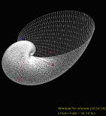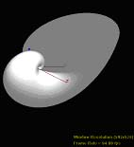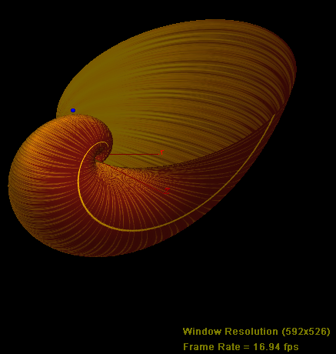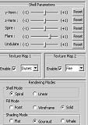
Figure 24: Ammonite

Both the ammonite and whelk shell structures were produced using the spiral mathematical model, which is chosen by selecting the spiral rendering mode radio button.

Figure 24 shows an example of an ammonite shell type. On start up this is the type of shell presented to the user. A main feature of the ammonite type shell is its cross section, which increases in size as the numbers of turns in the spiral are increased. From the wire frame model it’s possible to see the lengths of triangle strips which are integral to all the shell structures. The ammonite type shell has a spire value of zero, which means that the spiral path increases only in two planes, the x and y, z = 0.

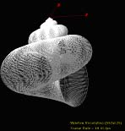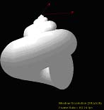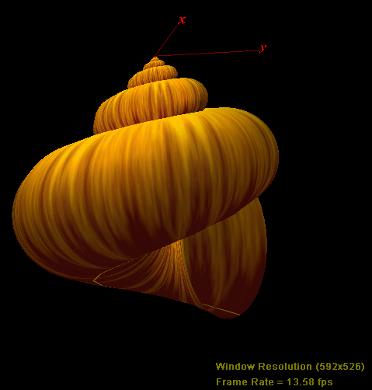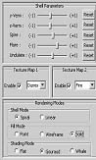
Figure 25: Whelk

The whelk shape is created in much the same way as the ammonite. To increase the number of turns in the spiral path, the angular separation between the neighbouring points is increased. The spiral path travels in the x, y and z domain thanks to a non-zero spire value. The values of parameters y-verm and z-verm were altered to allow correct fitting of successive spirals.

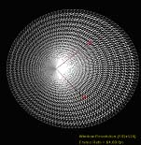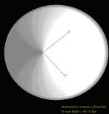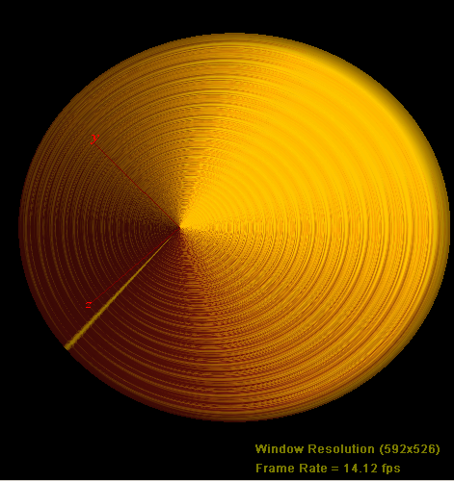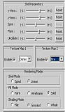
Figure 26: Limpet

Both the limpet and the tusk structures were produced using the linear mathematical model, which is chosen by selecting the linear shell mode radio button.

Rings form the structure of every shell. In the limpet example, they are formed along the x-axis with increasing separation between neighbouring rings. In this example, the limpet shape is formed by choosing large values for y-verm and z-verm. This gives the shell a very large opening in a small sweeping distance. The embossed rings are created by supplying a non-zero undulate value.

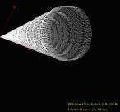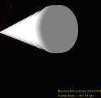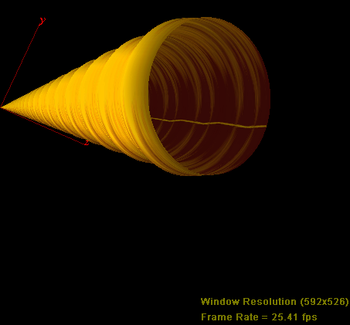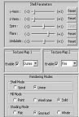
Figure 27: Tusk

The tusk is very similar in structure to the limpet shape. However, the y-verm and z-verm values are very small thus allowing more of a linear opening of the tusks cross section. The scale of the tusk is altered by changing the flare function. This particular tusk has a smaller opening at one end than it has at the other. Again the ripples in the shell surface are created by changing the value of undulate.

Many more shell shapes can be created, utilising many different lighting effects, textures etc. The examples above are some of the more familiar ones.

Appraisal

Appraisal 9

How the Software Compares to the Original Specification

The aim of the project was to create a system that implemented all the functions specified in stages 1 and 2 of the project proposal. The final system didn’t diverge too much from the original specification. There were ideas that weren’t implemented and ideas, which were additional to the original software. Extensions were not touched on because they were themselves, complex systems. How the software diverges is described below in more detail.

The 3D mathematical model was implemented exactly as originally planned. The specification is very vague with respect to which mathematical models should be used. However it was clear from initial research that the logarithmic spiral model was an effective way of creating a number of standard seashell forms. Initially only the spiral sweep path was going to be adopted, in the later stages of the project it became obvious that a linear path should also be used. Hence, allowing the user to change the mathematical models became more influential than originally foreseen.

In the original specification, the program was to consist of two windows. One would show the rendered shell whilst the other would show the shell parameter controls. The shell-rendering window was created successfully. When the time came to create the separate shell control parameter window, I couldn’t find any examples to work from. The direct3D samples, which were packaged with the SDK influenced my decision to integrate the two into one window using their MFC/DirectX template.

Program stage 2 of the project proposal clearly stated that the user should be able to perform functions such as Save, Save As and Open. Allot of time was spent constructing simple prototypes which implemented the Save and Open functions. The premise was to save an instance of the ShellVertices() object to file. To open the file, the ShellVertices() object file would be selected and copied into a new ShellVertices() object in the main file. The main problem stemmed from the need to make the ShellVertices() object and CustomVertex() object (which is used with in ShellVertices() ) serialisable for opening and saving to work.
This had a profound effect on the rendering of the seashell. With the serialisable function implemented, the rendered shell shape looked like a huge random mass.
Whilst this random mass of vertices could be saved, on opening the file, the rendering would not to change. After many attempts a decision was made to scrap saving and loading shells so that other parts of the program could be given more attention.

The specification stated that there should be a number of selectable graphical effects applied to the surface of the shell. Again, this was a grey area. The extent of the Direct3D 9 graphics library and capabilities of the graphics card supplied with the schools computers were not known. These limitations influenced which effects could and couldn’t be applied. In most cases however, the graphics card and DirectX9 combination allowed for the majority of implementable effects. An effect called DOT3 bump mapping was prototyped but wasn’t used in the final system due to time constraints. The texture mapping and lighting features were the most important and the most successful. The combination allowed effects, which went far beyond my original expectations.

Bugs and Fixes

A number of problems with this system have been hidden away so that the user never chooses them. For example, the variable number of circles, which made up the shell surface, could be varied by the user in the early stages of development. By increasing the number of circles, the number of vertices, which constitute the shell structure, also increases. The shell vertices are stored in the main program in a dynamic array. The size of this dynamic array is calculated by multiplying the number of sweep circles multiplied by the number of vertices per sweep circle multiplied by two (there are 2 vertices at each point). The number of elements in this dynamic array is specified at start up. If the number of vertices available is altered beyond this initial limit, the program crashes. I believe this problem may be more to do with my lack of understanding of a C++ concept.

A similar problem to that described in the previous paragraph was found when changing the number of cross sectional vertices. Again, if the number of vertices were increased beyond the initialised array limit, then the program would crash. To fix this problem, the program was initialised with the upper vertices limit i.e. the number of circle vertices selectable at start-up was set to this maximum number. The other problem that was caused by implementing this function was visually obvious. Bizarrely, when the number of circles were altered, a radial sweep artefact was evident i.e. a line which emanated from the centre of the spiral to the outer edge of the last swept circle.

One minor problem is visually evident on start up. It’s not so much a bug but an implementation problem. The first and last rings of vertices are excluded from the vertex normal calculation. This just means that the user sees a grey shadow at the ends of the lit tube. The lighting at the far end of the tube is most affected, where the distances between neighbouring circle’s vertices are at their maximum value. To fix this problem an additional mathematical algorithm would need to be introduced to the calculateVertexNormals() method of the ShellVertices() class. This additional algorithm would need process five distances in the vertex normal calculation instead of the standard eight i.e. the non existing vertices on the edges would be excluded.

Another visual inaccuracy, which was noticed towards the end of the project, was the inner surface vertex normal calculations in gouraud and flat shading modes. In the early design stages only the outer surface vertex normal calculations were given much thought. As the project progressed and the number of adjustable shell parameters increased, the error became more noticeable. A quick fix solution involved taking each of the repeated shell vertices and reversing their vertex normal coordinates. This produced the shading effect which is now called “whale”. The quick fix solution gave the surface of the shell a grooved like appearance i.e. each triangle strip was shaded from light to dark across its width. To light both surfaces, another shell layer would be required which is a separated by the other later by a tiny amount. The repeated layer would then have its vertex normal coordinates reversed.

In the later stages of development a loading mechanism was utilised to load and apply textures to the shells surface. A Direct3D function called D3DXCreateTextureFromFile was used to take a directory path or file name as an argument and saves the texture at a position in memory stored in a specified pointer argument. This pointer to a Direct3D texture image needed to be set to NULL every time a new texture was loaded from file or selected from the predefined list. This algorithm worked fine with predefined images that were stored in the project directory. It also worked fine when loading from file, until a predefined texture was again specified. This caused the program to crash unexpectedly. To fix this problem allot more testing would be required to pin point why this runtime error occurred.

Before switching to the MFC/DirectX template, the rendered shell was drawn in a simple DirectX window. In this window the user was able to change the orientation, scale of the shell and spot light by using the DirectInput mouse utility. This was possible because the window had a single, top level window handle (ID), required by DirectInput. Only the rendering environment was contained within that window. Hence all the mouse input affected only the rendered shell. When switching to the MFC/DirectX template, the top level window contained the rendering environment and the GUI control items. If the mouse was used with in the rendering window, its movement inadvertently affected the state of the GUI items. Hence, the idea of controlling the rendered shell using the mouse had to be discarded. A solution to the problem would involve disabling the whole GUI whilst the mouse button is held down.

Reliability and Robustness

Testing of the system was an ongoing process. When additional components were added, the new functionality was briefly tested. A rigorous test plan wasn’t followed at all stages of the software’s creation. When runtime errors did occur, the debugging environment found within the Visual C++ software package helped pinpoint the algorithm or data structure at fault.

A problem that caused the program to crash was evident in the later stages. This problem was caused by overwriting the pointer to the Direct3D vertex buffer every rendering cycle. The problem was fixed by initialising the vertex buffer once at program start up. Once this rendering problem was fixed, the system rarely, if ever crashed as new items were implemented.

The input data that the finalised system received was all predefined. This input was selected from predefined items and values from the GUI. Time was spent sitting down changing all the shell parameters to create the desired shell shape. Once the desired shell shape was captured, all the MFC GUI items were reset back to their original positions. This process was repeated for many different shell shape types. Over the period of time taken to use all the system’s features, it never crashed once. Obviously not all the different shell parameter values have been tested together. Given the number of adjustable parameters, testing every combination would be unfeasible.

Performance of the System

The actual minimum system requirements for this program are unknown. One major issue, which hasn’t been addressed, is compatibility of this program across the broad range of different graphics card, processor, RAM combinations. Testing these different hardware setups would be unfeasible; however it would need to be addressed if a commercial version of this software was to be published.

The response time of the system to user input depended heavily on the hardware. The school’s windows PCs had very quick processors (Pentium4) but incapable DirectX compatible graphics cards (Geforce2 MX). However, because the schools computers were to be used for demonstration purposes, the program would be tailored to them.

The actual response times of the program to user input was dependant on:

- The number of vertices on the screen at any one time.
- The size of the surface to be rendered.

If both these variables were at their maximum values then the frame rate of the program would slow down to approximately 1 frame per second. This would have a slight effect on the responsiveness of the mouse, but not noticeable enough to be impractical. This also did not affect the responsiveness of the GUI item’s parameter selection. The frame rate only affected the responsiveness of the key presses to the rotation of the shell.

In any case the only important thing in the program was the accuracy of the rendered image. Slow down and thus unresponsive keyboard input may have ensued, but the redrawn image present on the screen was always crisp, stable and rendered accurately.
Conclusions

Conclusion 10
The main aim of the project was to create a piece of software that would generate various 3D shell types from an initial standard shell shape. The software successfully achieves this aim and goes some way to produce rendered images that look realistic.
The program successfully encompasses the proposed shell rendering window and shell user interface. The outward appearance of the shell (the way in which the shell surface is rendered) can be changed effectively by changing the shell parameters available in the GUI. The shell can be transformed (scaled, translated, rotated) in any which way the user desires from either changes in the GUI parameter states or from keyboard input.

There were a number of deficiencies apparent with the software. The first related to the vertex normal calculations. If there was more time available, the vertex normal calculation for the inner surface and outer rings of the shell would’ve been successfully implemented.

In the original project proposal, saving and opening 3D rendered shells was mentioned. These options unfortunately did not make it into the final system. The main reason being, the implementation method used was problematic, leading to visual inaccuracies in the rendered shell. An alternative method of opening and saving would need to be found before work on this could again go ahead.

The option to load texture maps from file would’ve been a great addition, but never made it into the final system again because of implementation problems. The number of shell parameters that the user could modify went far beyond what was originally envisaged. This variety proved successful, however more trial and error testing is required to set their range and incremental updates correctly. If things had worked out differently, more control over the shape of the sweep path would be given to the user. The spiral path works effectively, however the linear path points needs to be made adjustable to cater for shell types that have different degrees of curvature in their sweep paths.

The number of rendering modes available was impressive, thanks to the inclusion of light and texture mode adjustability. However, there were some impressive rendering modes that could not be implemented because of the schools graphics hardware’s limitations. Given better hardware, effects like bump mapping could be implemented which would accurately imitate irregular surfaces. The undulate function went some way to add an uneven surface. However, the inclusion of such a function allowed very unrealistic shell formations when pushed to its limits. A rendering mode, which would be great to implement, but couldn’t because of time restrictions, was the reaction-diffusion model of pigmentation patterns. The reaction-diffusion model works on the principle of accurately “growing” shell textures following a set of defined algorithms.

The system didn’t quite meet the intended stage 2 completions. The loading functions would’ve given more scope on the programs reaction to unseen data. However, by excluding the load functions, the system proved to be more stable under test conditions. The usefulness and increase in the variety of parameters available to the user went some way to improve the usability of the program. There are parts of the project that would’ve been implemented differently given my current knowledge at the start of the project. This is a minor issue, which affects all projects. Overall the shell rendering was accurate and the GUI was functional.

References

References 11
- Clayton Waynum, Microsoft Direct3D Programming Kick Start, 2003

- Andre LaMothe, Tricks of the 3D Game Programming Gurus Advanced 3D Graphics and Rasterization Book, Jun 2003

- Microsoft, DirectX 9 SDK Help, Samples and Tutorials, 2003

- MFC Tutorials, http://www.functionx.com/visualc/

- Adding Windows XP theme style to current project, http://www.thecodeproject.com/w2k/xptheme.asp

- Visual C++ library, http://msdn.microsoft.com/library/default.asp

- C++ Programming Tutorials, http://www.cplusplus.com/doc/tutorial

- C++ Programming Tutorials, http://cplus.about.com/cs/ctutorial1/index.htm

- DirectX Tutorials, http://www.gamedev.net/reference/ list.asp?categoryid=24

- Cay Horstmann, C++ Essentials, 2002

- Richard Dawkins, Climbing Mount Improbable, W. Norton & Company, 1997

- Deborah R. Fowler, Hans Meinhardt and Przemyslaw Prusinkiewicz, “Modeling Seashells”, Computer Graphics, July 1992

- D’Arcy Wentworth Thompson, On Growth and Form, Dover Publications, Inc., 1952

- Hans Meinhardt, The Algorithmic Beauty of Sea Shells, Springer, 2002

Appendices

Appendices 12

Appendix 1: Project Proposal

What the project is about

The project entails developing a “shell growing” program. This program will allow the user to generate various shell types from an initial standard shell shape, which then can be viewed and manipulated.

How the project will be approached

There are a maximum of 4 possible stages that make up this project. The aim of the project can be achieved by completing just program stage one (the self-contained core shell growing program). Program stages 2, 3 and 4 are optional that are added to extend the functionality of the core shell growing program.

Program Stage 1

Program stage 1 will focus on the mathematics behind the 3-D seashell model. This stage will consist of 2 parts:
- The shell user interface window
- The shell rendering window
The shell user interface window will display a number of fields. Each field will be initialized to a set of values. These sets of values are used to calculate the initial 3-D mathematical model of the seashell structure; the 3-D seashell structure will be displayed in the shell rendering window. The user can then alter each or every field value; this will have the affect of changing the sea shell shape that’s displayed in the shell rendering window. The shell will initially be a wire frame model that can be viewed (scaled, rotated and translated) in whichever way the user desires.

Program Stage 2

Program stage 2 will introduce some additional features that focus more on the graphical attributes of the seashell. These additional features will be selectable from a toolbar in the shell rendering window. From the drop down menu the user will be able to choose options that allow manipulation of the shell’s outward appearance. A number of graphical effects applied to the shell surface will be selectable. The shell can be viewed as either a basic solid structure or a more realistic texture mapped version i.e. the shell walls will be either be filled with a solid colour specified by the user or wrapped up in a selectable texture. Additional rendering effects may be employed if time permits such as alternative shading (Phong, Gouraud,), texture mapping (bump mapping, reaction-diffusion), ray-tracing and X-Ray viewing.
The shell user interface will also include a number of toolbar menu items associated with the computer file system. From this the user will be able to perform functions such as:
- File: Save, Save As, Open etc
The number of toolbar options deployable will be time dependant.

Program Stage 3

If the initial program is completed before the deadline, work will go into the next phase of project development called “Program stage 3”. “Program stage 3” will consist of an additional 2 parts:
- A title screen window
- An evolution rendering window
This phase develops on the first and second phase by introducing aspects of artificial evolution. The evolution rendering window can be opened up via the shell user interface window toolbar options or via the title screen window. The evolutionary rendering window will require the user to load in 2 seashells; they can be chosen from either the user designed batch or from the templates batch (pre-designed seashells). Once loaded, a list of options will be available to the user. A new shell can be produced using any of the reproduction techniques such as:
- Crossover
- Mutation
- Cloning
The shell can then be saved or discarded.
A new option will be available in the shell rendering window toolbar. The “fitness test” option will be used to calculate the fitness of the seashell. The fitness is a number indicating how good the solution is. The perfect fitness level is achieved by creating/evolving a shell that has measurable attribute values that are the same as that chosen by me, the programmer. Once the ideal solution has been found, these ideal values are reset to a random set; the user can then again try to develop the ideal solution.

Program stage 4

Program stage 4 will be based on elements of the “pet” game called Tamagotchi. The purpose of this game is to grow the “perfect” shell. The shell grows by introducing stimuli. To progress to the next stage the shell must be “good enough” to attract the attention of the passing hermit crabs. If successful the next stage is entered, the time limit increased and the user controls where the shell should be moved to. The game ends when the time runs out.
To develop this game the title screen of “Program stage 3” will need to be redesigned. This will be the first screen that the player encounters; it will introduce the player and list game options such as:
- Play Game – New, Saved Game
- Evolve Saved Seashells
- Options – Graphics, Controls, Sound
- High Scores
If the new game option is chosen then the user is presented with a screen that allows him or her to enter their name. Once their name has been entered the next screen is in-game. They must initially enter the name of the shell. Once entered, they can then place their newly named shell anywhere within the confines of the beach. The beach consists of sand, water, rock and sun. Stimulus menu items can be found around the perimeter of the game window. Examples of external stimuli include:
- Food
- Music
- etc
The selectable stimuli and placement of the shell affects the shape, colour, texture and growth of the shell i.e. this effects the magnitude of the variables that belong to the mathematical equations that define the sea shell structure.
The time frame within which the shell metamorphoses will be chosen by trial and error.
There will be many stages to this game. In the first stage, given a time limit of one minute; in this minute the user must influence the correct changes in the shell’s structure. The user will know when this is the case when passing hermit crabs either choose or do not choose the users shell as a home. If the shell is picked up, then the user gains control of the hermit crab. The user is awarded steps dependant on how much the crab likes the new home. Once moved to its new location, the crab disappears and 1 minute is added to the clock. If the user’s shell is not picked up by the hermit crab in the given limit, then it’s game over.

Development Timetable

0 – 80hrs: Research and Prototyping
81 – 120hrs: Coding and development of Program Stage 1
121 – 400hrs: Coding and development of Program Stage 2
401 – 600hrs: Coding and development of Program Stage 3

NOTE: Program Stage 4 will commence if Stages 1 – 3 are completed well within the given development time.

Software and hardware details

Software
- Microsoft Visual Studio 6 programming environment
- Visual C++ to create the GUI and define the mathematics
- DirectX SDK to create and display the geometry
- (Optional) 3D Studio Max

Hardware
- Windows Labs PC’s

Appendix 2: User Guide

The source code for this project can be found in the following directory:

msc88drc/MySummerProject/Code/DirectXMFC/MFCDirectXApplication7/

Within this directory you will find all the C/C++ header and footer files used within the project. There are a number of JPEG and bitmap files used for texture mapping features. The program was created using Visual Studio .NET, hence included within this directory is a SLN (Visual Studio Solution Object) file with the same name as the directory.

The program must be run on a PC that uses the Microsoft Windows operating system. The PC must have a DirectX 9 compatible graphics card installed, which uses the latest DirectX 9 device drivers (please check your graphics card manual for directions on how to do this).

Change your directory to that stated at the top of the page. Within this directory you will find a folder named “Debug”. Open that folder, within this directory lays an application named “MFCDirectXApplication2.exe”. Double clicking on this file should bring up the integrated shell rendering program.

All the shell rendering options are selectable via the GUI items to the right hand side of the shell rendering window. Most of these are self explanatory. However, the lighting controls do need a mention. The position of the spotlight can be translated to any point within the 3D scene using the spotlight control spin buttons. The best lighting effects can be achieved when the ambient lighting is set to zero and the spotlight reset to its original position.

The view control functions are manipulated using the numpad keys and the pair of spin buttons located to the left and bottom of the shell rendering window. These can be used to translate the viewing camera in the x and y planes only. The numpad keys can be used to manipulate the rotation of the shell as follows:

- Numpad 8 – rotates the shell positively about the x-axis
- Numpad 2 – rotates the shell negatively about the x-axis
- Numpad 4 – rotates the shell negatively about the y-axis
- Numpad 6 – rotates the shell positively about the y-axis

